Good morning, Elected officials.

As you know, on 1/30/2024 I was denied the Public Documents Request for the Operations Manual for the ES&S DS-200 Vote Tabulators citing Idaho Code 74-105(4)(b) with the voting machines being part of the critical infrastructure. Understandable.

Question: Does Boundary County have a copy of the DS-200 Operators Manual. Have you read it?

Could a county commissioner or law enforcement have access to it?

There have been many problems with the DS-200 around the country. Here are a few of the more egregious ones.

As you can see below using the ES&S DS-200 vote tabulators in the Mail-in-Ballot Category 1 Election Summary for the 11/3/2020 election, there were 12,211 ballots cast blank in Montgomery County Maryland. Example below.

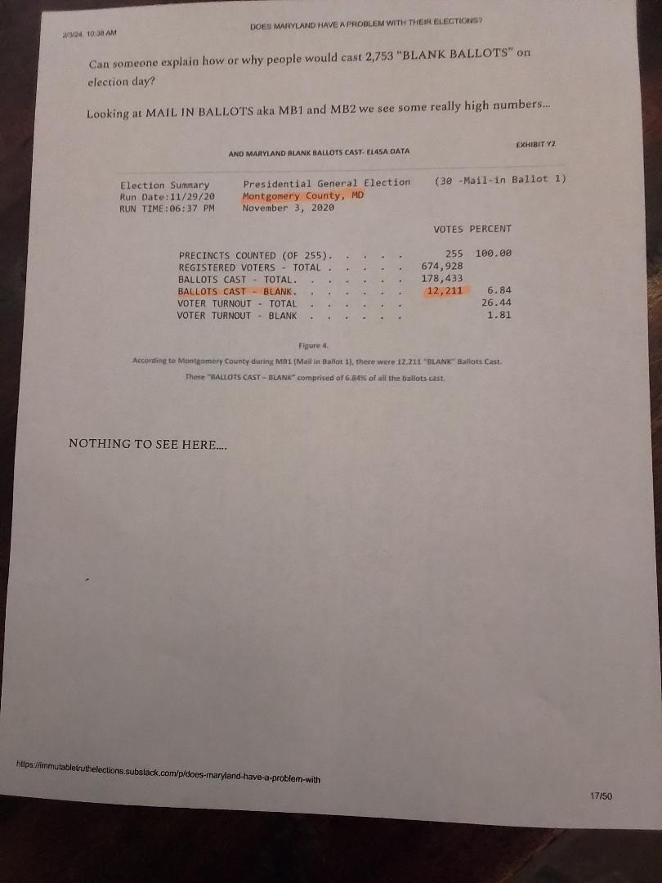

Apparently there are settings in the Admin Mode of the DS-200 that allow blank or under votes to be scanned without an alert out-stacking the ballot for adjudication by hand. This is like sending a blank check in the mail for whoever opens it to fill in the blank spot.

From the report I read there were over 17,000 ballots scanned blank in the State of Maryland.

Here is a link to that report , there are a few screenshots of what appears to be the Operations Manual for the DS-200. An easy fix to this would be a check box on the ballot that says None of the Above.

<https://immutabletruthelections.substack.com/p/does-maryland-have-a-problem-with>

Next question: Modems I know that from what I have read in the Boundary County ES&S Sales Agreement dated 10/20/15 there is a line item that says quote, “no Wireless“. I am assuming that means no wireless modems were sold in that sales agreement. However, I was able to obtain a troubleshooting guide for the DS-200 from Anoka County, Minnesota . It explains in detail how to reboot a modem. Example below.

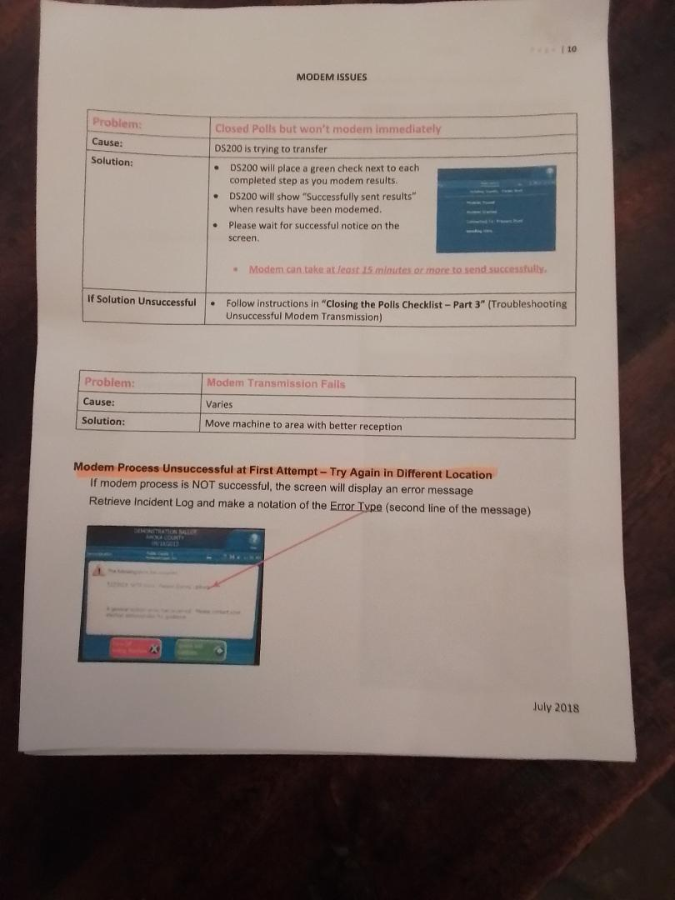

Here is a link to that guide:

<https://www.manualslib.com/manual/1809358/EsAnds-Ds200.html>

Question: How are we assured that there are no wireless or analog modems in our voting machines when the company won’t allow anyone including the county to open and check for ourselves? Other counties were told that there no modems. Yet they have found analog modems. For example: ES&S machines had analog modems in 5 counties in North Carolina. Here is the report:

<https://www.carolinajournal.com/modems-removed-from-voting-machines-in-five-n-c-counties/>

There are other reports around the country about an undetectable First Responders Network “FIRST NET” being used for vote machines as part of Homeland Security. Here is a link to a fascinating report about a “FIRST NET Cellular Network“ being used in vote tabulators and E poll books. Idaho does not allow modems in the vote tabulators but does allow E poll books to be online.

It's no wonder they won’t let citizen oversight see the users manual due to “Critical Infrastructure“.

<https://joehoft.com/bombshell-exclusive-nationwide-cellular-network-connects-election-equipment-and-gives-federal-government-access-to-election-systems-at-the-precinct-level/?utm_source=substack&utm_medium=email>

ES&S does not have a good record of being honest with its customers about imbedded modems. Here is a 2020 report from Politico … hardly a right-wing conspiracy theory news outlet.

<https://www.politico.com/news/2020/08/13/election-voting-machine-misleading-claims-394891>

The report decribes how ES&S markets the DS-200 as EAC certified and describes how some of the volunteer voting standards are violated making them uncertifiable .

Next question: Encryption.

I am no tech genius but there are reports around the country that a vote tabulator was hacked in a courtroom in Fulton County, Georgia by a computer expert with a pen and a USB stick within just a couple of minutes. He had the ability to flip votes without being detected. Here is a link to that report including the related court documents.

<https://www.thegatewaypundit.com/2024/01/breaking-professor-election-expert-j-halderman-hacks-dominion/>

In the Boundary County ES&S Sales Agreement the list of third party items purchased says quote, “no DDPE Encryption Software.”

I am to assume that means that if the machine is hacked the coding and election management software is in plain text and can be manipulated without any special tools or knowledge.

I realize that the hacked tabulator was not an ES&S model but from my understanding they all work on the same logic and principles.

Question: Would encryption make the tabulators less vulnerable to hacking? How does this reconcile with EAC standards?

Here is an excerpt from the EAC Manua, page 42, paragraph 1

Use of software should be limited to the very basic functions required to perform the voting system’s processes. In addition, the software should provide audit logging to track the sequence of events that occur on the system and, to the extent possible, identify the person(s) who initiated the events. The software should also employ a sufficient level of encryption or validation protocols to prevent changes made without proper authorization.

Here is a link to the EAC manual:

<https://www.eac.gov/sites/default/files/electionofficials/EMG/EAC_Election_Management_Guidelines_508.pdf>

Next Question: Photocopied ballots

Last October during the L&A test in Canyon County, Idaho an observer suggested that a ballot be photocopied to see if the tabulator would accept it and count it.

It Did. The Secretary of State’s office was contacted and the election went on as scheduled. Here is a link to that article:

<https://idahodispatch.com/canyon-county-voting-machine-accepts-photocopy-of-ballot-during-test-another-test-scheduled-thursday/>

Copied ballots have come up in recent court cases in other counties:

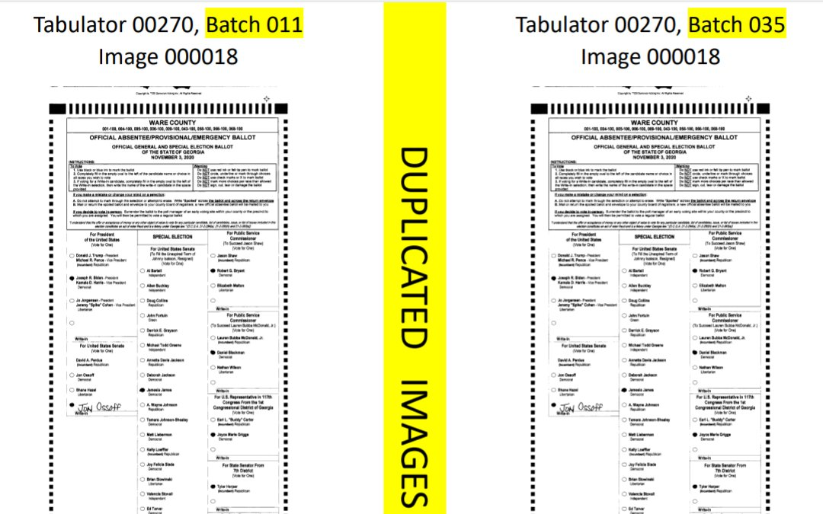

Fulgham v. Ware County Board of Elections concerning flipped votes and fake duplicate ballots from Georgia 2020. Yesterday, April 25, 2024 I filed a request with Superior Court to allow us to inspect the physical ballots. We've already submitted image evidence showing 100…

[[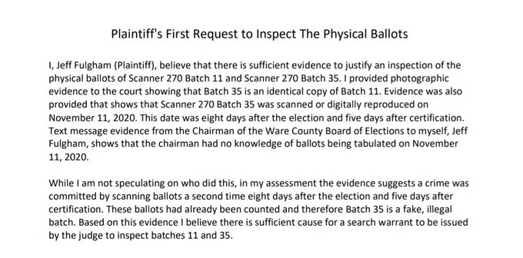](https://twitter.com/jeffmfulgham/status/1783894875642999212/photo/1)](https://twitter.com/jeffmfulgham/status/1783894875642999212/photo/1)

This is not internet rumors; it is an actual court case under sworn testimony. Image evidence submitted to Ware Superior Court shows 100 fake duplicate ballots (nearly 1% of this small county's total) were counted and included on the cast vote record. Electronic records show that fake batch 35 was scanned (or digitally reproduced) for the second time 5 days after certification

The issue of

TITLE 34

ELECTIONS

CHAPTER 9

BALLOTS

34-901. OFFICIAL ELECTION BALLOT IDENTIFICATION. (1) The county clerk shall provide that all election ballots are identified as official. Each ballot shall have upon its face the date and year of the election in which it is used and the words "Official Election Ballot."

(2) The clerk in a county that utilizes optical scan ballots shall ensure that:

(a) The official election ballot identification is printed on each ballot issued; and

(b) Each ballot contains a unique marking to prevent duplication of official election ballots.

Question: Is Boundary County in compliance with 34-901?

Canyon County, Idaho contacted the vendor and the issue was corrected. The unique marking is circled in red on the Canyon County ballot. This ballot was rejected by the Heart InterCivic tabulator because it was already scanned.

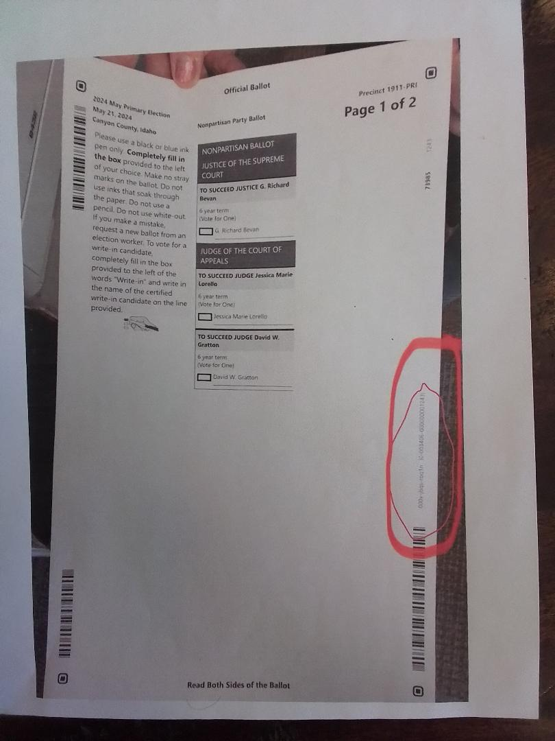

The County Clerk of Canyon County resigned/retired a couple of months after the November 2023 election.

Here is the official record:

<https://www.canyoncounty.id.gov/canyon-county-clerk-chris-yamamoto-to-retire/>

Next Question: Cast vote records, CVR’s.

Here is an excerpt from a report from the South Dakota Canvassing Group where cast vote records were first denied they even existed and then were denied as proprietary information. Lawsuits are now in progress.

South Dakota uses ES&S tabulators to count your votes. Tabulators are like office copy machines; they scan your ballot and convert the marked ovals into a digital record of the votes. These digital vote records are CVR’s. This digital data can be exported into spreadsheet format for analysis and auditing. The second part of a CVR is the ballot image. (picture of the ballot) The image of the ballot is saved digitally and also used for auditing. In instances of real audits of the 2020 election, analysis of these records has proven machine driven fraud.

This report has many links from previous reports, as the story developed including a transcript of the newly elected Minnehaha County Clerk confronting seven ES&S executives. This started the lawsuit process.

Here is a link to that transcript and nobody knows why the image capture feature was turned off.

<https://southdakotacanvassinggroup.substack.com/p/es-and-s-task-force-and-transcript?r=1tsbt6&utm_campaign=post&utm_medium=web&triedRedirect=true>

This activity concluding with an ES&S making a confession.

Questions:

We know the ES&S DS-200 is capable of producing an auditable trail including ballot images. Are CVRs subject to a Public Documents Request? How do we know that the ballot image feature is turned on within the admin system settings?

Bonner County has provided an Excel spreadsheet of their CVR.

Here is a single page of that public document. I have the entire file.

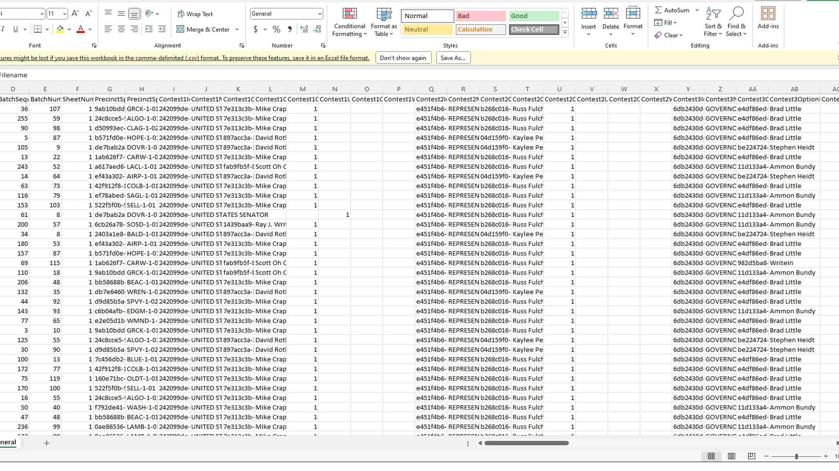

I would encourage anyone to read the report about CVRs in Ada County where they are making CVRs available to the public in general without a PRR. Thus bolstering public trust in elections.

Here is a link to that article:

<https://boisedev.com/news/2024/04/23/ballot-verifier-ada-county-elections/>

There are some other questionable details of the ES&S DS-200 vote tabulators such as:

Is there a System Setting that allows a single ballot to be scanned more than once on the same insert? I have seen supposed screenshots of this setting.

What is the emergency plan if the scanners are not working, i.e., as in Maricopa County using the Dominion Vote tabulators. These tabulators were rejecting 3,000 ballots an hour due to the printing company having printed a 19-inch image on a 20-inch ballot. This resulted in the scanner not aligning properly and caused 4-hour wait times disenfranchising thousands of voters.

What measures provide security to comply with the new HB599 prohibiting ballot harvesting using the outdoor drop box? Is facial recognition software being used? If not how is this being accomplished?

Here is a link to that bill:

<https://legislature.idaho.gov/wp-content/uploads/sessioninfo/2024/legislation/H0599.pdf>

Will the Canvass Report that is required by HB 561 be issued to the public upon completion before or after it is submitted to the Board of Canvassers?

Here is a link to that bill:

<https://legislature.idaho.gov/wp-content/uploads/sessioninfo/2024/legislation/H0561.pdf>

Now about ES&S, the company :

**Source: Wikipedia**

**Election Systems & Software (ES&S or ESS)** is an [Omaha, Nebraska](https://en.wikipedia.org/wiki/Omaha,_Nebraska)-based company that manufactures and sells [voting machine](https://en.wikipedia.org/wiki/Voting_machine) equipment and services.[[1]](https://en.wikipedia.org/wiki/Election_Systems_%26_Software) The company's offerings include vote tabulators, [DRE voting machines](https://en.wikipedia.org/wiki/DRE_voting_machine), voter registration and election management systems, ballot-marking devices, electronic [poll books](https://en.wikipedia.org/wiki/Poll_books), ballot on demand printing services, and absentee voting-by-mail services.

In 2014, ES&S was the largest manufacturer of voting machines in the United States, claiming customers in 4,500 localities in 42 states and two U.S. territories.[[*citation needed*](https://en.wikipedia.org/wiki/Wikipedia:Citation_needed)] As of 2014, the company had more than 450 employees, over 200 of whom are located in its Omaha headquarters. ES&S is a subsidiary of the McCarthy Group. (An investment banker)

(The terms of the Sales Agreement contain terms such as:

Prohibited Use

Terms of license

Updates

1 year conditional warrantee

Exclusive Remedies)

Proprietary Rights. Customer acknowledges and agrees as follows: ES&S owns the Software, all Documentation and training materials provided by ES&S, the design and configuration of the Equipment and the format. layout, measurements, design and all other technical information associated with the ballots to be used with the Equipment. Customer has the right to use the aforementioned items to the extent specified in this Agreement. ES&S also owns all patents, trademarks, copyrights, trade names and other proprietary or intellectual property in, or used in connection with, the aforementioned Items. The aforementioned items also contain confidential and proprietary trade secrets of ES&S that are protected by law and are of substantial value to ES&S. Customer shall keep the Software and related Documentation free and dear of all claims, liens and encumbrances and shall maintain all copyright, trademark , patent or other Intellectual or proprietary rights notices that are set forth on the Equipment, !he Software, the Documentation, training materials and ballots that are provided, and all perm\Used copies of the foregoing.

Sole Provider; Access. Customer shall not permit any individual other than an ES&S Representative to provide maintenance or repairs with respect to the Products for so long as the Initial Term or any Renewal Period is in effect. Customer shall provide ES&S Representatives with all information necessary to enable them to provide Hardware Maintenance Services. Customer shall likewise provide full access to the Products and adequate working space for all Hardware Maintenance Services performed at its Designated Location, including sufficient heat, lights, ventilation, electric current and outlets.

(This to me is like buying a car and the contract says the Seller is the only one who can change the oil)

My opinion: We are sub-contracting our elections to a private third party NGO

That is not certifiable

that is not subject to citizen oversight

that is not subject to internal inspection

that is not subject to PRR’s

that is compensated with taxpayer dollars meant to pay public employees to do this job.

Who knows what the software contains?

Who knows the programmer’s agenda?

The data belongs to the county; but the data can only be read by a proprietary device.

In closing, my intent is not to antagonize or to relive past elections. My intent is to protect future ones.

The County Clerk is the Chief Elections Officer of the County and is duty bound to provide clean, fair, lawful elections .

The Board of canvassers is the last stop in a lawful election certification. Not a rubber stamp. We must examine the smallest details before the certification occurs.

We all saw before our very eyes what happened in the 2020 pandemic election. It is my intent to not let that happen to our country ever again through citizen oversight.

What if the Tabulators are not able to follow the law? Would you be in favor of using them . The evidence shown here is an example of how things could and do go wrong . If it can be proven that simple, clean, reliable, transparent, lawful elections, can be provided I would be in favor.

We have hundreds of years history of counting ballots by hand where we can see what happens yet we are trusting a machine with all of these problems . We count municipal elections by hand here in our County

I would be in favor of a simple, transparent, reliable voting machine but this one has a proven record.

This letter does not include many other forms of election interference problems, bias propaganda news, voter roll problems, campaign finance problems (Smurfing ) ,universal mail in ballots mandated by a so called emergency pandemic which by the way has a survival rate of over 99% by a lab created virus., lawfare including untimely prosecution during a presidential campaign strictly for political reasons , censorship as seen in the sworn Congressional testimony of the Twitter Files , and outright lying. There is a long road ahead to reform election law.

This letter is meant to focus on the vote machines that we use here in Boundary County and their vulnerabilities. I could easily write equal threads on each of the above topics

The election integrity movement is real and growing .

The problem, as I see it, is the protective and dictatorial nature of the for-profit company and how vulnerable the machines really are. Transparency and accountability are paramount in a Democracy.

I wanted to make this letter available to you, and hear your comments before I considered publishing it as a letter to the editor

Thank you,

Dave Ingle